Name _______________________________________

Worksheet 3 Plotting

1. Data can be encoded in several different aspects of a plot. Name as many of these as you can (e.g., the horizontal axis)
2. What aspects of a plot are useful for encoding discrete data? What about continuous data?
3. What makes this a good plot and what makes this a bad plot?

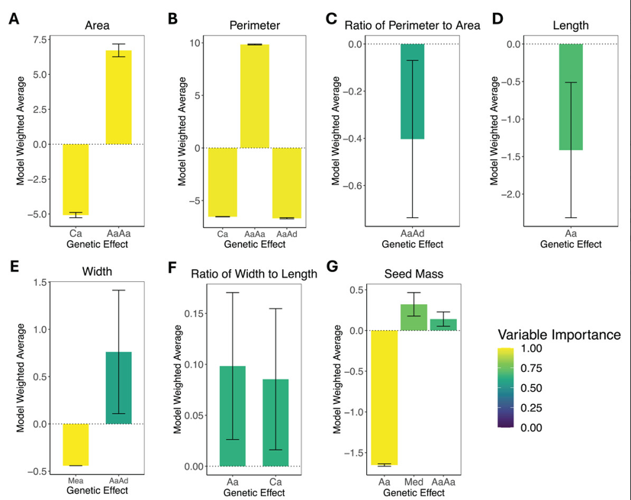

1. What makes this a good/bad plot

